**AUMOR-AR: Augmented Reality-Based Mobile Application for University Orientation**

**Abstract:** The transition to university life can be overwhelming for new students, especially when navigating campus environments and accessing essential resources. In response to this challenge, this study introduces AUMAR, a mobile application designed to enhance university orientation through GPS and QR code technologies. The application aims to provide seamless navigation, information retrieval, and campus exploration to new students. By leveraging GPS functionality, AUMAR offers real-time location-based services, including route guidance to academic buildings, student services, and recreational facilities. QR code integration allows users to access relevant information by scanning codes at key campus locations. This paper presents the development process of AUMAR, including its conceptual framework, design considerations, and implementation plan. Furthermore, it discusses the results of user testing and evaluation, highlighting the application's usability, effectiveness, and potential impact on university orientation. Through its innovative features and user-friendly interface, AUMAR demonstrates promise in facilitating a smoother transition for new students and optimizing their university experience.

**Keywords:** Augmented Reality (AR), Mobile application, University orientation, Navigation, Technology acceptance model (TAM), Situated learning theory, Location-based services

1. **Introduction**

Every year, hundreds of thousands of students leave college and enter university to become successful professionals. As institutions of higher learning, universities are crucial for helping students develop their intellectual capacity and prepare for the demands of the working world. In addition to imparting information, higher education aims to provide students with the life skills they need to succeed in the workplace and daily life (Attereya2021). University orientation programs serve as critical transitional experiences for new students entering higher-education institutions. Students who participated in this program often performed better academically than those who did not attend the orientation. program. Elements such as psychological support, academic understanding, and social integration are crucial for effective adaptation. Orientation not only motivates students but also helps them build solid social networks and adjust to the academic environment much better (Mohazana).

Traditional orientation methods, although valuable, may not always adequately address the diverse needs and preferences of modern learners and cost fortune as well. For example, orientation fees in the U.S. range from $100 to over $500 per student, with UNC-Chapel Hill charging $232 and Stanford $525. Program budgets often exceed $250,000, reaching $1 million at institutions like the University of Oregon. Canadian orientation fees average C$90 (~US$63), funded through student fees and university support. Australia uses Student Services Fee for free "O-Week" events. European orientations are typically free, funded by universities and student unions. Larger institutions, especially in the U.S., spend more due to larger intakes, while smaller and non-U.S. universities use modest funding models. Orientation remains a valuable investment in student success. In recent years, advancements in mobile technology have offered new avenues to enhance the orientation process. Mobile applications have emerged as powerful tools for delivering personalized and interactive experiences to students. By leveraging features such as GPS navigation and QR code scanning, mobile applications can revolutionize the way students engage with their university environments. The integration of augmented reality (AR) technology further extends the capabilities of mobile applications by offering immersive and interactive experiences that blend digital content with the physical world. By overlaying virtual information in real-world environments, AR applications can provide students with contextualized guidance, information, and engagement opportunities during university orientation. The global augmented reality market size was estimated at USD 83.65 billion in 2024 and is expected to grow at a CAGR of 37.9% from 2025 to 2030.

Implementing augmented reality (AR) for university orientation can offer numerous benefits, such as enhancing student engagement and providing immersive experiences. AR provides an interactive way for students to familiarize themselves with the campus environment, degree programs, and course curricula. This interactive approach can reduce students' fear of failure and prevent educational withdrawal by making them more comfortable with their new learning environment (Ngyuen). AR applications can significantly increase student engagement and motivation. For instance, an AR-based lab orientation application, AR-LabOr, was found to be more engaging and supportive compared to traditional methods, helping students better understand lab equipment and safety rules (Nadeem). AR can improve spatial orientation skills, which are crucial for navigating a new campus. A study showed that students using AR for landscape interpretation improved their spatial orientation skills significantly compared to those who did not use AR (Carrera).

Furthermore, Campus life often feels like a survival challenge: students race between buildings, get lost indoors, and juggle multiple apps that don’t show what’s inside a building or how to reach services on time. The result isn’t just tardiness, it’s a steady drain on energy, productivity, mental clarity, and confidence. This is less a time-management issue than a design problem, revealing the need for a smarter, student-centric tool. AUMAR addresses this by serving as a personalized campus companion: AR “radar” highlights nearby labs, classrooms, study zones, cafés, and library rooms; floating labels show names and distances; QR scans open videos, documents, websites, room maps, and booking pages; and a quiz reinforces orientation knowledge. In short, AUMAR unifies wayfinding and information access to make daily academic life faster, smarter, and calmer—avoiding the chaotic, inefficient days that happen without it.

The motivation for this research stems from the recognition of the challenges faced by new students during the orientation process and the potential of MAR technology to address these challenges. By developing a GPS and QR code-based AR mobile application tailored specifically for university orientation, we aim to provide incoming students with a seamless and intuitive tool for navigating campus, accessing relevant information, and fostering a sense of connection to their academic community. Through this research, we seek to explore the feasibility, effectiveness, and impact of integrating GPS and QR code technologies with AR capabilities in the context of university orientation. By addressing this gap in literature, we aim to contribute valuable insights and practical solutions to enhance the orientation experience of new students and to support their successful transition into university life.

* 1. **Research Problem and Objectives**

University orientation programs often face challenges in effectively assisting new students in navigating campus facilities, accessing relevant information, and fostering their sense of belonging. Traditional methods may not fully cater to the diverse needs and preferences of modern learners, leading to inefficiencies and gaps in the process of orientation.

The objectives of this study are as follows:

* Design and develop a mobile application that integrates GPS navigation, QR code scanning, and augmented reality (AR) features to facilitate university orientation for incoming students.
* Implement GPS-based navigation functionalities to provide real-time guidance and directions to academic buildings, student services, and key campus locations.
* Integrate AR technology to overlay virtual information into physical campus environments, allowing users to explore campus landmarks, points of interest, and relevant resources.
* QR code scanning capabilities enable users to access relevant information and resources by scanning QR codes placed at strategic locations across the campus.
* Curate and organize educational content, campus maps, event schedules, and other orientation materials within the mobile application for easy access and retrieval.
* Conduct usability testing and user feedback sessions to assess the ease of use, functionality, and user experience of GPS and QR code-based AR mobile applications.
* Measure the effectiveness of the application in supporting new students' orientation experience, including their ability to navigate campuses, access information, and engage with orientation materials.
  1. **Significance of Study**

Mobile applications allow students to access educational content anytime and anywhere by using smartphones or tablets. This level of accessibility enables flexible learning opportunities and accommodates diverse schedules and preferences. Implementing QR code scanning functionalities will empower new students to access relevant information and resources conveniently and on demand, thereby facilitating a smoother transition into university life. Augmented reality (AR) technology is used to create immersive and interactive experiences that engage new students in their campus environment, fostering a sense of connection and belonging. It provides valuable insights and practical solutions to enhance university orientation practices through the development and evaluation of a GPS and QR code-based AR mobile application.

This paper is organized as follows. Section 2 reviews the related work on university orientation and navigation systems, focusing on the use of GPS, QR codes, and machine learning technologies. Section 3 outlines the proposed methodology, detailing each of the system's key modules, including location tracking, QR code scanning, and the machine learning model for personalized navigation. Section 4 provides an overview of the implementation process, highlighting the integration of GPS and QR technologies. In Section 5, the experiments and results are presented, including the evaluation criteria and case studies conducted within the university campus. Section 6 discusses the performance of the prototype, emphasizing its accuracy, user experience, and adaptability to different campus environments. Finally, Section 7 offers the conclusions and proposes areas for future work, such as potential improvements and broader applications of the system.

1. **Literature Review**
   1. **Overview of University Orientation Practices**

University orientation programs play a crucial role in facilitating the transition of new students into the academic community. These programs are designed to provide incoming students with essential information, resources, and support to help them acclimate to campus life and succeed in their academic endeavors.

Orientation sessions are typically held before the start of the academic term and provide new students with an introduction to the university's policies, procedures, and academic requirements. These sessions may include presentations by university officials, faculty members, and student leaders. Campus tours are organized to familiarize new students with the physical layout of the campus, including academic buildings, residence halls, dining facilities, and recreational areas. These tours often highlight key campus landmarks and points of interest. Information sessions cover a wide range of topics relevant to student life, including academic advising, course registration, financial aid, campus safety, and student support services. These sessions aim to address common questions and concerns of new students. Resource fairs bring together various campus departments, organizations, and services to provide new students with information and resources. Students have the opportunity to learn about academic programs, extracurricular activities, health and wellness services, and campus involvement opportunities. Academic advising sessions help new students plan their academic schedules, select courses, and set educational goals. Advisors provide guidance on degree requirements, course sequencing, and academic policies. Peer mentorship programs pair new students with experienced peers who can offer guidance, support, and advice throughout their transition to university life. Peer mentors may assist with academic planning, campus navigation, and social integration. Orientation events and activities provide opportunities for new students to connect with their peers, build relationships, and engage in campus life. These may include social gatherings, recreational outings, team-building exercises, and cultural celebrations. Many universities offer online orientation resources, such as webinars, videos, and interactive modules, to supplement in-person orientation sessions. These resources allow students to access information at their own pace and on their schedule.

* 1. **Role of Mobile Applications in Education**

Mobile applications have significantly transformed educational practices, reshaping how students’ access, engage with, and process educational content. The widespread use of smartphones and tablets has created flexible, interactive, and personalized learning experiences beyond traditional classroom limitations (Chandran et al., 2022; Naveed et al., 2023). This popularity also engages more research in the field; a recent systematic review of Scopus-indexed literature indicate a substantial increase in research on mobile learning between 2018 and 2022 (Mercan et al., 2024).

The accessibility offered by mobile devices enables students to engage with educational content anytime and anywhere, effectively overcoming geographical and temporal barriers. This flexibility is particularly crucial in higher education, where students often balance multiple responsibilities and benefit from adaptive learning solutions (Naveed et al., 2023). Mobile applications provide easy access to resources such as texts, instructional videos, discussions, and assignments, substantially enhancing student engagement and motivation (Briz-Ponce et al., 2017).

Interactive and personalized multimedia features within mobile applications cater to diverse learning styles, fostering deeper cognitive engagement. Commonly integrated tools, including interactive quizzes, simulations, and adaptive learning pathways, dynamically adjust to individual student progress and performance (Chandran et al., 2022). This personalized approach supports innovative instructional methods like microlearning (Samala et al., 2023) and offers timely feedback, facilitating self-regulated learning and allowing students to identify and address areas needing improvement. Chandran et al. (2022) demonstrated through a meta-analysis of 15 studies with 962 participants that mobile application usage significantly enhances academic performance compared to traditional methods.

Moreover, mobile applications enhance collaborative and communicative practices within educational settings. They enable real-time interaction between learners and educators via messaging, discussion forums, group projects, and shared documents, promoting peer-to-peer learning irrespective of location. According to transactional distance theory, mobile learning can effectively bridge the psychological and pedagogical gap between learners and instructors. By reducing transactional distance through enhanced interaction and adaptive content, mobile learning facilitates individualized and collaborative learning experiences, enriching educational outcomes (Park, 2011). As such, mobile-computer-supported collaborative learning (mCSCL) particularly shows strong evidence of enhancing collaborative outcomes (Sung et al., 2017). Additionally, mobile learning fosters essential digital literacy and critical 21st-century skills such as problem-solving, critical thinking, and technological fluency, which are invaluable for future academic and career success.

Beyond instructional applications, mobile apps significantly streamline administrative and supportive functions in educational institutions. Universities and schools employ dedicated apps for registration, orientation, scheduling, institutional communication, and resource access, thereby enhancing overall operational efficiency (Chandran et al., 2022). Assessment and feedback features embedded in mobile applications offer educators real-time insights into student progress and learning outcomes. Data analytics facilitate the monitoring of student engagement, the identification of learning patterns, and adaptive instructional strategies (Naveed et al., 2023). This data-driven educational approach ensures that instructional interventions align closely with individual student needs.

Despite numerous advantages, implementing mobile applications in education presents specific challenges, including digital equity, technological literacy disparities, device compatibility issues, network connectivity problems, and privacy concerns. Educational institutions must strategically address these challenges, ensuring inclusivity and accessibility for all students.

In summary, mobile applications have become integral to contemporary educational ecosystems, offering dynamic, engaging, and effective learning opportunities that substantially enhance educational outcomes.

* 1. **GPS and QR Code Technologies in Navigation Apps**

Navigation applications have become integral tools for users to navigate efficiently through physical environments. The integration of the Global Positioning System (GPS) and Quick Response (QR) code technologies in these apps have significantly enhanced their functionality, accessibility, and usability. This literature review explores the role of GPS and QR code technologies in navigation apps by examining their individual contributions, integration possibilities, and implications for the user experience.

GPS technology has revolutionized navigation by providing accurate positioning and location tracking capabilities. According to Cahn and Markert (2017), GPS enables the real-time tracking of user locations using satellite signals, allowing navigation apps to provide turn-by-turn directions, route optimization, and location-based services. The ubiquity of GPS-enabled smartphones has led to the widespread adoption of navigation apps such as Google Maps and Waze, which leverage GPS technology to offer seamless navigation experiences. Huang et al. (2019) highlighted the importance of GPS accuracy and reliability in navigation apps, emphasizing the need for continuous advancements in GPS technology to enhance location accuracy, particularly in urban environments with high-rise buildings and signal interference. Despite its benefits, GPS technology may face challenges, such as signal loss in dense urban areas or indoor environments, prompting researchers to explore alternative positioning methods or hybrid solutions to improve navigation accuracy (Li et al., 2018).

QR code technology offers versatile means of encoding and retrieving information using smartphone cameras. In navigation apps, QR codes serve as digital markers that users can scan to access location-specific information, points of interest, and navigation instructions. According to a study by Hsiao et al. (2019), QR codes are commonly used in tourist navigation apps to provide contextualized information about landmarks, historical sites, and tourist attractions. Liu et al. (2017) explored the potential of QR code-based navigation systems in indoor environments, such as shopping malls, airports, and museums. QR codes placed at strategic locations within indoor spaces enable users to navigate complex environments, locate amenities, and access relevant information, without relying solely on GPS signals. This approach enhances indoor navigation experience and addresses the limitations of GPS in indoor settings.

The integration of GPS and QR code technologies offers synergistic benefits for navigation applications by combining real-time location tracking with on-demand information retrieval. According to Chen et al. (2020), navigation apps can utilize QR codes as supplementary navigation aids, providing users with additional context, direction, or points of interest along their route. This hybrid approach enhances the richness of navigation experiences and improves user engagement. Recent advancements in augmented reality (AR) technology have further expanded the possibilities of GPS and QR code integration in navigation applications. AR-based navigation apps overlay digital information, such as route directions, points of interest, and location-based alerts, onto a user's real-world environment in real time. This immersive approach enhances situational awareness and facilitates intuitive navigational experiences (Kushleyev et al. 2021).

* 1. **Previous Studies on Mobile Apps for University Orientation**

Many universities have adopted augmented reality (AR) applications as an innovative approach for students to explore the campus independently, reducing the need for staff involvement and saving both time and resources typically required for guided tours. The development of AR technology for campus orientation and tours was first introduced by Columbia University, which employed head-mounted displays along with GPS and orientation tracking to present campus visitors with tour information in the form of 3D graphics (Feiner et al., 1997). Fu-Jen Catholic University was one of the pioneers in utilizing AR specifically for helping new students become familiar with the campus layout (Chou & ChanLin, 2012). Similar initiatives were launched at Lehigh University and University of Columbia, where AR apps were developed to help users identify buildings (D. Li et al., 2014) and provide comprehensive campus tours (Low & Lee, 2014) [36], respectively. Some of these applications even offer features like indoor location detection and tracking (Hamza-Lup et al., 2018), as well as voice-command search for locating and sharing places (Al Delail et al., 2012). At Bowling Green State University, AR apps were employed to help visitors explore campus cultural activities or events and guide them to specific locations (Chao et al., 2014; Wong, 2013).

An AR application developed by Yu et al. at Chung Hua University incorporated audio and visual elements to provide information on the campus’s ecological environment, including details about the flora and fauna, creating an environmentally friendly navigation system (M. Li et al., 2021; Yu et al., 2015). Similarly, Giraldo et al. implemented an AR-based virtual tour at the University of Quindio (UQ), featuring a 3D directional board that leads visitors to various campus locations (Giraldo et al., 2016). At Mil. Nueva Granada University, Garay-Cortés and Uribe-Quevedo created an AR application aimed at guiding new students by integrating landmarks on campus that trigger mini-games through location services and a dynamic map (Garay-Cortes & Uribe-Quevedo, 2016).

Some AR systems allow users to access information simply by taking photos of locations, with the images being processed to detect the places and display relevant details on the screen (Özcan et al., 2017). At Haaga-Helia University of Applied Science (UAS), Nguyen et al. designed an AR application to assist students who miss orientation week, allowing them to catch up on essential information (Nguyen et al., 2018). At Management and Science University (MSU), Andri developed AR and virtual tour applications that enable users to point their smartphones at signboards to access hidden details such as building descriptions, staff information, or even cafeteria menus. An additional feature allows off-campus users to view a 360-degree panoramic view of campus buildings and facilities (Andri et al., 2019). Finally, Mobile AR has been utilized at the Autonomous University of Nayarit to create an autonomous learning process that helps users discover campus locations. This system provides information about degree programs, curricula, and the main buildings on campus (Iriarte-Solis et al., 2016).

* 1. **Implications for User Experience and Accessibility**

The integration of GPS and QR code technologies into navigation apps has significant implications for user experience and accessibility. These apps enhance navigation efficiency, reduce cognitive load, and improve overall user satisfaction by providing users with accurate location information, contextualized guidance, and on-demand access to relevant information (Wu et al., 2018). However, ensuring the accessibility and usability of navigation apps for all users remains challenging. Guan et al. (2020) emphasized the importance of designing inclusive navigation interfaces that consider the diverse needs and preferences of users, including individuals with disabilities or limited mobility. Incorporating features, such as voice guidance, haptic feedback, and customizable interfaces, can enhance accessibility and usability for all users.

In conclusion, GPS and QR code technologies play crucial roles in enhancing the functionality and usability of navigation applications. The integration of these technologies offers synergistic benefits by combining real-time location tracking with on-demand information retrieval to provide users with a seamless navigation experience. Advancements in AR technology have further expanded the possibilities of GPS and QR code integration, offering immersive and intuitive navigation solutions. As navigation apps continue to evolve, researchers and practitioners must consider the diverse needs of users and strive to create inclusive and user-friendly navigation interfaces that enhance accessibility and usability.

1. **Theoretical Framework**
   1. **Conceptual Basis of AUMAR**

The conceptual basis of the application involves integrating GPS, QR codes, and AR technologies synergistically to provide users with a seamless and enriched experience. GPS technology allows for accurate positioning and tracking of user locations using satellite signals. By integrating GPS functionality into the app, it can determine user positions relative to their surroundings, enabling features such as real-time navigation, location-based alerts, and personalized recommendations. QR (Quick Response) codes serve as digital markers that contain the encoded information. When scanned using a smartphone camera, QR codes can quickly retrieve specific content such as website URLs, text, images, or multimedia. Integrating the QR code scanning functionality into the app enables users to access relevant information and resources by simply scanning designated QR codes placed throughout the physical environment. AR technology superimposes digital content, such as images, videos, or 3D models, onto a real-world environment, creating an augmented view of reality. By overlaying virtual information onto physical spaces, AR enhances users' perceptions of their surroundings and enables interactive experience. In the context of the application, AR can be utilized to provide users with contextualized information, interactive guides, virtual tours, and gamified experiences that enhance their engagement and immersion within the environment. Together, these technologies create a powerful platform for delivering personalized context-aware experiences that cater to the diverse needs and preferences of users during university orientation and beyond.

* 1. **Theoretical Perspectives on Mobile Learning and Navigation**

The theoretical framework for GPS and QR code-based Augmented Reality (AR) applications encompasses several key theoretical perspectives that inform its design, development, and implementation.

Situated Learning Theory emphasizes the importance of context and social interactions in the learning process. Within the context of GPS and QR code-based AR applications, Situated Learning Theory informs the design of contextualized learning experiences situated within the physical environment. By embedding educational content, interactive challenges, and guided exploration into the user's surroundings, the application facilitates experiential learning and knowledge acquisition that are directly relevant to the user's immediate context. The Information Processing Theory focuses on how individuals acquire, process, and retain information. This theory informs the design of information retrieval mechanisms and cognitive support features in the context of GPS-and QR code-based AR applications. By optimizing the presentation of information, providing scaffolding and guidance, and incorporating interactive elements, the application enhances users' information-processing capabilities and facilitates effective learning and decision-making. User Experience (UX) design principles encompass a set of guidelines and best practices for creating intuitive, engaging, and satisfying user experiences. Drawing on principles such as simplicity, consistency, feedback, and affordance, UX design informs the design of the application interface, navigation flow, and interaction design. By prioritizing user needs, minimizing the cognitive load, and maximizing usability, the application enhances user satisfaction and engagement with the AR experience. Spatial cognition and navigation theory explore how individuals perceive, interpret, and navigate spatial environments. In the context of GPS and QR code-based AR applications, this theory informs the design of spatially aware features such as GPS-based navigation, augmented reality overlays, and landmark recognition. By leveraging users' spatial cognition abilities and providing intuitive spatial cues, the application enhances their navigation efficiency and spatial understanding within the physical environment.

* 1. **Technology Acceptance Model**

The adoption and use of information technologies have long been recognized as delivering both immediate and long-term benefits at organizational and individual levels, including improved performance, efficiency, and convenience. In the 1980s, with the rise of personal computers, research on technology adoption gained prominence, but early studies lacked empirical insights into user responses to system performance. Prior research emphasized user involvement in system design and the evaluation of system characteristics yet relied heavily on subjective performance measures that were often unreliable and weakly correlated with actual use. To address these shortcomings, scholars turned to the Theory of Reasoned Action (TRA) to explain attitudinal drivers of behavior, but its generic nature limited its application to information systems. Recognizing the need for a more tailored framework, Davis (1989) developed the Technology Acceptance Model (TAM), grounded in TRA but specifically focused on technology use. It provides a theoretical foundation for understanding users' acceptance and adoption of technology. By examining factors such as perceived usefulness, ease of use, and attitude toward technology, TAM helps to predict and explain users' intentions to use GPS and QR code-based AR applications. TAM insights can inform the design of user-friendly interfaces and features that align with users' needs and preferences, thereby enhancing acceptance and adoption. It explains how individuals accept and adopt new technologies by focusing on two key factors: perceived usefulness (PU) and perceived ease of use (PEOU). PU refers to the extent to which a person believes that using a system enhances their performance, while PEOU reflects the belief that using the system requires minimal effort. These beliefs shape users’ attitudes toward using technology, which then influence their behavioral intention to use it and, ultimately, their actual system use. TAM also recognizes the role of external variables, such as system design, user characteristics, training, and support, which impact both PU and PEOU. Moreover, PEOU not only directly influences attitudes but also enhances PU, as users are more likely to find a technology useful if it is easy to operate. The model is valued for its simplicity and predictive power, and it has become a foundational framework in information systems research, often extended with additional constructs like social influence, enjoyment, and facilitating conditions to better capture diverse adoption contexts.

1. **Methodology**
   1. **Research Design**

The research adopted a sequential exploratory design, beginning with qualitative data collection and analysis, followed by quantitative data collection and validation. This approach allows for an in-depth exploration of user experiences, preferences, and challenges before quantitatively assessing the application's performance and impact.

* 1. **Data Collection Methods**
     1. **Research Subject**

A total of 128 participants, including undergraduate students (aged 19–22) and staff from the electrical engineering department, participated in the study which included both male and female. All participants were engineering students (and staff), and the majority of them belonged to the third and fourth year of an undergraduate computer and electrical engineering program. Additionally, the participants had previously experienced augmented reality in one way or another.

* + 1. **Research Sample Selection**

The students taught by the researchers were invited to take part in the survey. The student who volunteered themselves were recruited to participate in this study. If a participant decided to withdraw after providing consent, the next participant was contacted. The participating students and facilitators belong to the same department (ECSE). The survey was conducted at the AUM Campus during University hours, but outside lecture hours. The participants were chosen on a first-come first-serve basis and did not receive any reward for their participation.

* + 1. **Research Procedure**

If a student was willing to participate, a meeting was scheduled with the student where only one researcher and the participant(s) were present. The researcher conducted the evaluation and explained to the participant(s) about the research and the procedure to carry out the test. The participants were provided with an Android smartphone with an orientation application (AUMOR-AR) pre-installed on it. Participants were informed that they were taking part voluntarily and that they could exit the study at any point without any personal consequences. Users were allowed to use the application in the vicinity of the campus and undergraduate laboratories. Each feature of the application had a tutorial pop-up that appeared as soon as it was launched. This was done to guide students and reduce their dependency on assistance. Once the participants used the application, they were asked to complete a paper-based questionnaire evaluating its performance, comfortability, usefulness, and helpfulness. The questionnaires were created using a 5-point Likert scale to provide better understandability and easy quantification of the responses. The survey assessed how easy and intuitive the application was to use, the effectiveness of the application in helping students understand the information, and the relevance of the augmented content.

* + 1. **Research Ethics**

This research involved human participation and required approval from the Ethics Approval Committee. The protocol was approved by the concerned authorities at AUM (reference xxxx). The research required interactions between students conducting the survey and the participants. Therefore, the identity of the participants was known to the researcher and anonymity was impossible. The questionnaire provided to the participants was anonymous and did not contain any information that could help identify the participants.

* + 1. **Apparatus**

The study was mostly conducted with an Android-based Samsung Galaxy S10 Wi-Fi SM-T700 16 GB model running Android 9.0 Pie with Samsung Exynos Octa-Core CPU processors, 2 × 2.73 GHz Mongoose M4 and 2 × 2.31 GHz Cor-tex-A75 and 4 × 1.95 GHz Cortex-A55, an ARM Mali-G76 MP12 GPU graphics card, and 3 GB LPDDR3 RAM. Alternatively, students could download this application from the playstore and install it on their phone. We made use of the built-in technologies of the mobile for the AR system, such as the camera to capture real-world views, a touch screen for interaction, and speakers to play music.

* + 1. **4.5. Questionnaire**

A short questionnaire comprising two parts was designed to evaluate the mobile AR-based application The first part used a 5-point scale, ranging from strongly disagree to strongly agree, to capture the response of participants, and the second part collected open-ended feedback in terms of likes/dislikes and suggestions. Six questions in the questionnaire focused on the quality of the application design and how easy it was to use the application as well as the learning experience of the FSM, including learning interest, engagement, active learning, level of understanding, academic outcome, and the extent to which the participants would like to have the respective learning tool applied in their class. As mentioned earlier, we based our questionnaire on TAM3 [54] to measure the rate of student acceptance of the use of the AR4FSM app. We selected and adopted the questions presented by [31]. We omitted simple technology-related questions, as these did not apply to engineering students, especially ECSE students who were tech-savvy and highly experienced. The questions in the questionnaire are listed in Table 1.

1. **Implementation Plan for University Orientation**
   1. **AUMOR-AR architecture**

Figure 1 depicts the AUMOR-AR architecture. It consists of a remote data server and a wirelessly linked mobile client application that runs on the Android operating system (OS) platform, which communicates with each other using the JSON protocol. The user engages with the application by using the camera and GPS built into the device to scan the QR code and provide the user's position, respectively. Both the camera and GPS feed their data into the AR Display, which becomes the user's interaction layer with the application. The user request, which includes GPS coordinates and scanned QR information, is structured in JSON format and sent to the remote server. This ensures interoperability and lightweight data handling. The JSON-formatted AR contents are kept on a server or repository like GitHub. The OGAR parses the JSON format that the server provides in response to this request in real time and incorporates it into the display. The globe icon on the right represents the GitHub cloud repository, which stores and serves AR content dynamically. The server parses the incoming request, matches the data with appropriate AR content, and sends a JSON-formatted response containing AR assets such as text, images, or videos. The AR content of AUMOR-AR can be updated dynamically on the server without recompiling the mobile app. This design saves time, resources, and simplifies content maintenance for developers and administrators.

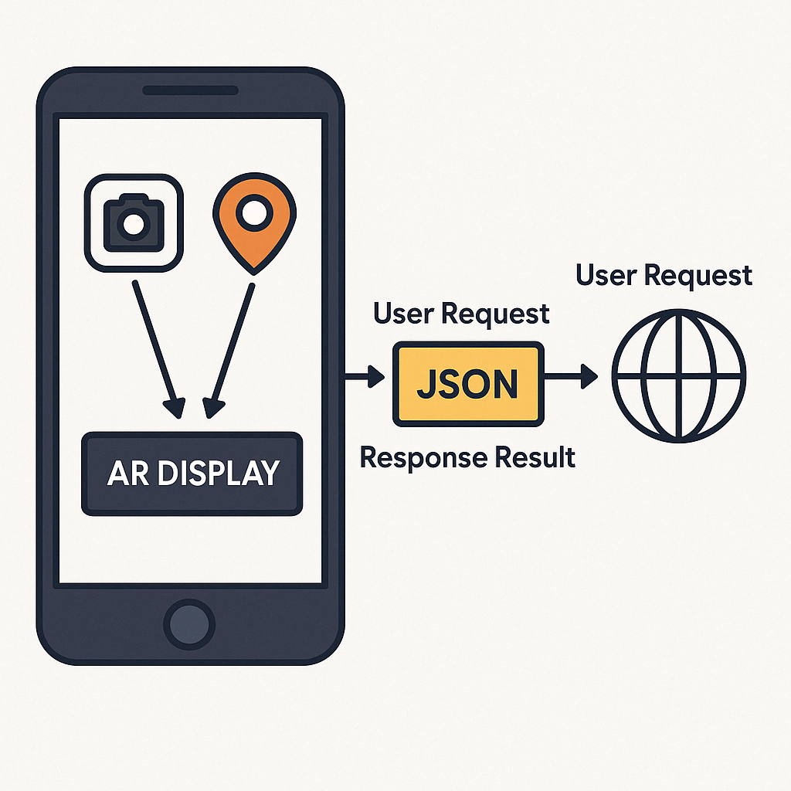

Figure 1: System architecture

* 1. **Development Process of AUMOR**

We used an incremental development model for mobile application development, which is an iterative approach that involves breaking down a project into smaller, manageable increments or iterations. Each iteration focused on delivering a specific set of features or functionalities, allowing for continuous improvement and adaptation throughout the development process. The Begin outlines the overall goals and objectives of the mobile application. Identify the core features and functionalities that are essential for the initial release as well as any additional features that can be added in future iterations. We then prioritize features and functionalities based on their importance and impact on the app's success. Factors such as user needs, market demand, and technical complexity are considered when determining the priority of each feature. The first increment includes the most critical features necessary to create a functional version of the app. This may involve basic functionalities, such as user authentication, navigation, and core functionality. Develop and test the features included in the first step. The focus is on creating a stable and reliable foundation for the app, ensuring that the core functionalities meet the requirements and expectations of the users. Gather feedback from stakeholders, users, and usability testing sessions to evaluate the first increment. This feedback is used to identify areas for improvement and to prioritize changes for future iterations. The development process was iterated by adding new features and functionalities in subsequent increments. Each increment builds upon the previous one, gradually expanding the app's capabilities and addressing the user’s feedback and requirements. Integrate new features into the app regularly and deploy updates to users as soon as they are ready. This allows for the continuous delivery of value to users and enables rapid adaptation to changing market conditions and user needs. The app's performance and user engagement metrics are monitored to identify opportunities for optimization and refinement. Use analytics tools to track user behavior, identify usability issues, and make data-driven decisions for future iterations. As the app gains traction and user adoption increases, consider scaling up the development efforts to add more advanced features and expand the app's functionality. Continue to prioritize features based on user feedback and market demand to ensure ongoing success. An ongoing feedback loop with stakeholders, users, and the development team is maintained throughout the incremental development process. Regularly solicit feedback, gather insights, and incorporate changes to ensure that the app evolves in alignment with user needs and expectations.

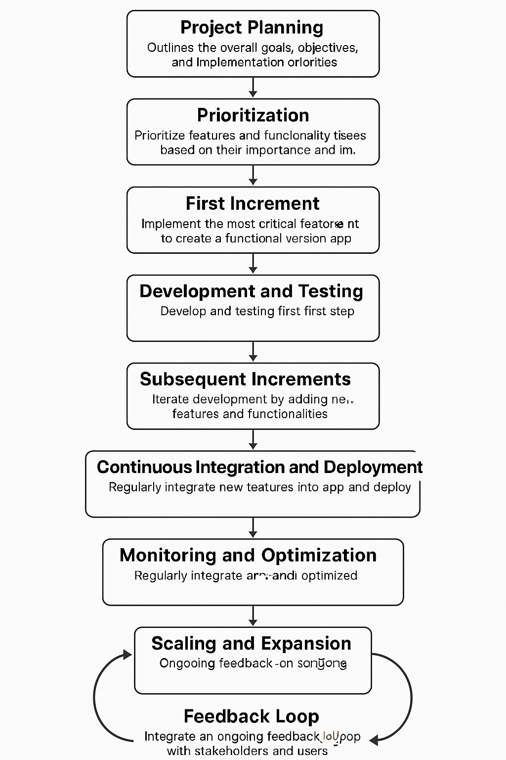

* 1. **GPS Integration for Location-Based Services**

The app uses GPS-based navigation to deliver information the moment a student nears a relevant place on campus. As they approach a building, service counter, or outdoor venue, the app activates an AR overlay that anchors to the scene and offers context-specific resources—short web links, quick videos, campus maps, downloadable PDFs, and, where appropriate, simple booking actions (e.g., study rooms or event check-ins). Pairing GPS with AR means students see what matters for the spot they are standing in, reducing search time and helping first-time visitors move confidently between locations.

To build this experience, we mapped key campus points of interest and recorded their precise coordinates using the campus base map (via Google Maps or the university GIS). Each location was added to a lightweight JSON catalog that stores its name, latitude/longitude, a geofence radius, and the set of AR assets to show on arrival. On the app’s map view this appears as a circle around each location (the geofence) and red markers for individual points—twenty-five in our pilot—so students can see what’s nearby at a glance while content updates remain centrally managed.

In use, when a student enters a geofence, the app displays the location name; tapping it opens an AR panel with the available options. A student nearing, say, the Administration Building would see a prompt that expands to office hours, a two-minute “where to go” video, a floor plan with accessible entrances, a PDF of common forms, and links to advising or fee portals. The interaction mirrors the QR flow described earlier but is hands-free: the system triggers automatically by proximity. Assets are streamed from the web to keep the app small, with essential items (maps, hours, emergency contacts) cached for spotty connectivity. This GPS-plus-AR approach turns the campus into an interactive guide, giving students timely, trustworthy information as they navigate orientation.

* 1. **QR Code Implementation for Information Retrieval**

For university orientation, we pair AR with QR codes placed at key locations (building entrances, labs, classrooms, offices, service counters, event booths, study spaces, parking, prayer rooms). Each code encodes a short URL or ID that the app reads with the camera and resolves against a lightweight JSON catalog mapping that ID to an up-to-date content bundle (e.g., map route and floor plan, 30–120s video tour or safety clip, PDF guide or checklist, links to portals like advising/registration/menus/bus schedules/parking status, and contact details with office hours). On scan, the app presents these options as an AR overlay (and accessible list view); tapping opens the selected asset online, keeping the app small while allowing centralized updates without reprinting codes. This scan-to-experience flow delivers just-in-time information where students stand, speeds wayfinding, and reduces friction for new users; success depends on clear, high-contrast code placement with labels (“Scan for office hours & directions”), reliable Wi-Fi or selective pre-caching of critical assets, and simple analytics to see which locations and resources are most used so content can be refined continuously.

* 1. **User Interface Design and Navigation Flow**

The user interface (UI) flow of the AUMOR-AR mobile application developed for university orientation is provided in Figure 2. The sequence begins with the app’s icon on the device home screen (first panel), providing quick access to the system. The second and third panels show the log-in screen, where users are required to input their email and password credentials. The log-in interface features a clean and minimalistic design, with a password visibility toggle, “forgot password” option, and a sign-up prompt for new users. Once authenticated, users are directed to the main feature menu (fourth panel). This menu contains four core functionalities:

* GPS Guide – for navigation and location-based orientation within the campus.
* QR Scanner – to retrieve contextual information and resources by scanning QR codes placed across the university facilities.
* Start Quiz – an interactive feature designed to reinforce orientation knowledge through gamified learning.
* Tutorial – offering guidance and instructions to new users, enhancing ease of use and adoption.

Together, these interfaces demonstrate the application’s student-centered design, emphasizing simplicity, accessibility, and the integration of location-based and interactive tools for effective orientation.

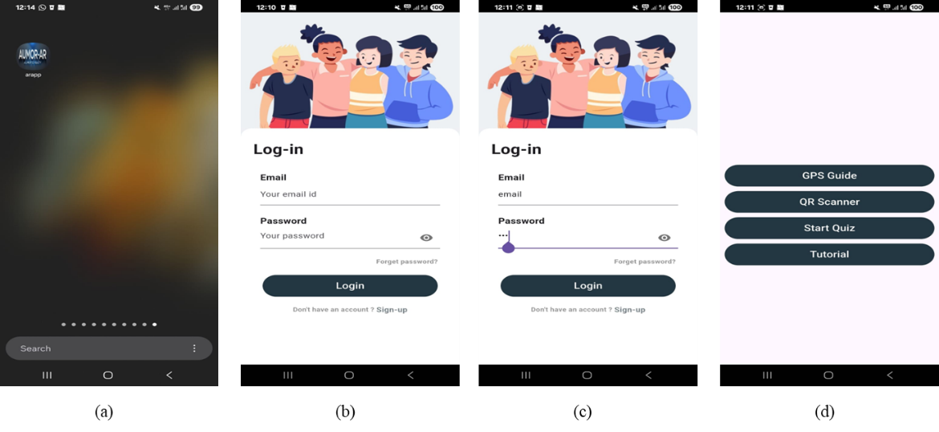

Figure 2. User interface flow of the AUMOR-AR application

Figure 3 illustrates the Augmented Reality (AR) navigation and information system of the AUMOR-AR application, designed to support students during university orientation. In the first panel, the system overlays a radar-style marker on the real-world environment, identifying nearby locations such as laboratories, classrooms, study zones, cafés, and library rooms. Floating labels provide contextual information, including the name of the facility and its distance from the user, thereby enabling intuitive, location-aware navigation.

In the second panel, multiple markers are displayed simultaneously, allowing users to view several facilities within range, such as business buildings, computer labs, tutoring centers, and capstone project rooms. This functionality provides a comprehensive situational overview, reducing the cognitive load of navigation in large or unfamiliar campuses.

The third panel demonstrates the interactive information panel triggered when a user selects a location. This panel provides access to rich multimedia and resources, including videos, documents, website links, and room maps, as well as booking options. Such features extend the utility of AR beyond navigation, transforming it into an integrated learning and resource platform for orientation and daily campus use.

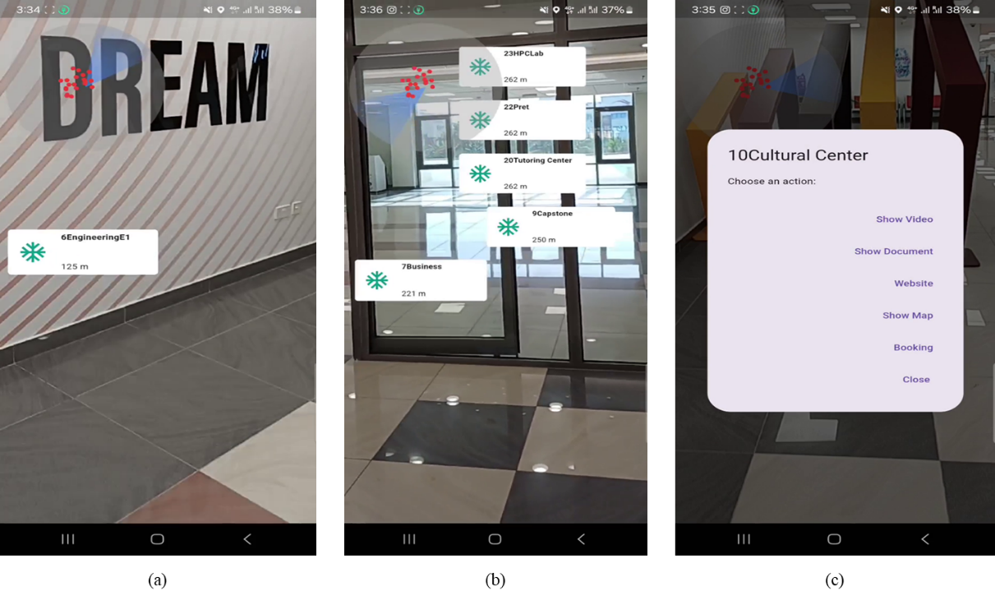

Figure 3. Augmented Reality navigation and resource interface of the AUMOR-AR application

* 1. **Augmented Reality Features and Functionality**
  2. **Application Features**
  3. **Overview of the Mobile AR Application**
  4. **User Interface Design and Navigation Flow**
  5. **Interactive AR Elements for Campus Exploration**

1. **Result**

In this section, we provide the evaluation results of our application. The data collected was analyzed using R software version 4.0.3. The internal consistency of the survey is very good, with Cronbach’s Alpha of 0.927688. The overall Cronbach's alpha for this study was *α* = .928 (very good). Broken down by subscale, the internal reliability was *α* = .837 (good) for perceived usefulness, *α* = .734 (acceptable) for Perceived Ease of Use, *α* = .822 (good) for ATU, *α* = .828 (good) for BIU, and *α* = .521 (bad) for AU. The low value for AU is expected as options provided for these questions are distinct features, not parallel items tapping one latent construct. The total number of 128 participants is composed by 39.84% males and 60.16% females, with their current academic levels reported in Table ***1*** Most of the participants are junior (36.72%) and sophomore students (31.25%).

**Table 1.** Participant demographics.

|  |  |  |  |  |  |  |  |  |
| --- | --- | --- | --- | --- | --- | --- | --- | --- |
| Characteristics | Attributes | | | | | | | Total |
| Participant Gender | Male (51) | | | Female | | | | 128 |
| 39.84% (51) | | | 60.16% (77) | | | | 100% |
| Participant Age (Years) | Freshmen | Sophomore | Junior | | Senior | Faculty | Staff | 128 |
| 12.50% (16) | 31.25% (40) | 63.72% (47) | | 15.63% (20) | 3.13% (4) | 0.78% (1) | 100% |

Participants are generally comfortable with mobile apps, and a clear majority already use them for learning: about one-third (32.81%) report using mobile applications for educational purposes often, and over a third (≈35%+) say they sometimes do so—meaning roughly seven in ten engage in educational use at least intermittently. Only a small minority reports minimal engagement, with just 4.69% using them rarely and 1.56% never using them for education. Taken together, these figures suggest strong readiness for app-based learning tools and imply that modest onboarding and targeted use cases could convert occasional users into more frequent ones. Regarding familiarity with AR, Error! Reference source not found.shows that most respondents 57.03% (73) have not used an AR app before while 40.63% (52) reported prior AR use; 2.34% (3) did not answer. This means the campus AR app is new to many students, which helps explain the sizable neutral responses in ease-of-use/usefulness items—many are first-time users still forming opinions. Practically, this points to the value of lightweight onboarding (60–90-second tutorial, tooltips, “try this” tasks during orientation), clear terminology (e.g., anchoring, recenter), and performance polish to build early confidence. It also suggests analyzing outcomes by AR familiarity: prior users should, on average, report higher perceived ease and usefulness; if not, that signals usability gaps specific to the app rather than novelty effects.

* 1. **Perceived Usefulness**

The breakdown of perceived usefulness of the AR application is shown in Figure *2*. Majority of the survey participants find the AR application useful in terms of understanding the university campus layout (60.16%) and finding useful information about campus facilities (75%) as well as in terms of overall orientation experience (57.82%). For most of the participants (74.22%) using the AR app saves time in finding important campus locations and it helps with confident campus navigation (57.03%).

Figure 4. Breakdown of the perceived usefulness of the AR application.

* 1. **Perceived Ease of Use**

Figure 3shows thebreakdown of the perceived ease of use of the AR application. Most of the survey participants find information about different campus locations easily using the AR application (71.88%). They also find the AR app simple to learn and to use (70.32%), and they do not require additional instructions to understand how to use the application (49.22%). The AR app is quick in responding according to 54.68% of the survey participants, with user-friendly layout and design (66.41%), and it is not difficult to use it (52.35%).

Figure 5. Breakdown of the perceived ease of use of the AR application.

* 1. **Attitude Towards Use (ATU)**

The ATU results are broadly positive as shown in Figure 4. Students most strongly endorse the concept as 75.79% (47.66% Agree, 28.13% Strongly Agree) believe using the AR app is a good idea for orientation, with only 2.34% disagreeing and 18.75% neutral. They also find it engaging: 71.10% (46.88% + 24.22%) say the app is a fun way to explore the campus; just 8.59% disagree and 17.19% are neutral. Personal experience is solid but more mixed: 58.60% (40.63% + 17.97%) feel confident navigating with the app, while 30.47% are neutral and 7.04% disagree. Similarly, 53.91% (37.50% + 16.41%) enjoy using it during orientation, with a relatively high 35.94% neutral and 6.25% negative. Nonresponses are small (3% each item). In short, students buy into the idea and fun of AR, but a sizeable neutral bloc on confidence and enjoyment suggests room for onboarding and usability polish (quick tips, clearer labels, performance smoothness) to convert the undecided into enthusiastic users.

Figure 6. Breakdown of the attitude towards the use of the AR application.

* 1. **Behavioral Intention to Use (BIU)**

Figure *5*shows thebreakdown of the behavioral intention to use the AR application. The survey participants are willing to recommend the AR application to other students or new entrants (75%) and would prefer to use it over traditional methods for orientation (53.90%). Many of the survey participants (52.35%) plan to continue using the AR application during their time at the university.

The Behavioral Intention to Use (BIU) results shown in Figure *5*are strong overall as 75.0% would recommend the AR app to other students (42.19% Agree, 32.81% Strongly Agree), with only 7.03% negative and 14.84% neutral. Preference over traditional orientation methods is positive but more mixed: 53.9% favor the AR approach (33.59% Agree, 20.31% Strongly Agree), while 29.69% are neutral and 11.72% disagree—suggesting many are open to AR but still comparing it with familiar formats. Intent to continue using the app during university is similarly moderate: 52.35% positive (35.94% Agree, 16.41% Strongly Agree), 32.81% neutral, and 10.16% negative.

Figure 7. Breakdown of the behavioral intention to use the AR application.

* 1. **Actual Use (AU)**

The breakdown of the usage of the different features of the AR application is shown on *Figure 6*. We can observe that the survey participants used the AR app mainly for campus navigation (51.56%) and for finding information about lab equipment (39.06%). Around one third of the participants used the AR app also for finding specific buildings or departments (29.69%), gathering information on student services (28.91%) and for accessing event schedules (27.34%). Some participants were also interested in virtual tours of the campus (18.75%).

Figure 8. Breakdown of the usage of the different features of the AR application.

Figure 7shows the frequency of the usage of the AR application during orientation. We can observe that 34.38% of the survey participants used the AR application during their orientation a few times and 17.19% of them used the AR app regularly throughout the orientation, while 10.94% used it only once.

Figure 9. Frequency of the usage of the AR application during orientation.

Figure 8shows the intended usage of the AR application after the orientation. Most of the survey participants are likely or very likely to continue using the AR application after the orientation (57.03%).

Figure 10. Intended usage of the AR application after the orientation

We performed an inductive thematic analysis to the open-ended item “What kind of information would you like to see on the application?” The responses were multi-coded, so totals can exceed 100% and outcomes are provided in Table

|  |  |  |  |
| --- | --- | --- | --- |
| **Theme** | **What Students want** | **Approx. share** | **Example snippets** |
| Real-time status / availability | Live parking occupancy, building or café crowding, bus schedules, event/class updates, power/AC status, whether instructors are in office (online/offline) | ~25–30% | “available parking; if the building is crowded or not”; “real time bus schedules and cafeteria menus”; “real time updates about campus events” |
| Events & schedules (with reminders) | Event dates/tables, schedules by major/semester, reminders/notifications | ~20–25% | “events (date, when?)”; “event schedules for all majors”; “events table”; “reminders” |
| Academic info & student services | Grades/GPA, assessment-level grades, course projects, *student affairs/faculty office hours*, doctor email, guides for future subjects | ~30–35% | “Maybe if it could show the students’ grade in each assessment”; “What GPA I have”; “office hours of faculty… course projects” |
| Navigation & wayfinding | Campus navigation to buildings/rooms; schedule-linked routing | ~25–30% | “Campus navigation”; “when I click on my class it shows me the way”; “places of every building” |
| Booking & utilities | Book study rooms, workshops/labs; general “useful info” | ~5–10% | “book spots/rooms for studying”; “booking workshop like robotics” |
| Onboarding/help & usability | Full campus guide, FAQ for new students, clearer info; “user-friendly navigation” | ~10–15% | “more clear information”; “A full guide… with feedback”; “a FAQ section for new students” |
| Accessibility & UX enhancers | Voice and text narration; “voice feature that saves time”; AR views in different conditions; ratings for doctors | ~5–10% | “voice and text narration”; “honest review for doctors’ ratings”; “see the campus in different conditions” |
| Security/technical | App security/power | ~2–3% | “Security powering the application” |
| No additional request / unsure | Nothing / perfect / IDK / N/A / didn’t use | ~30–40% | “Nothing, everything is perfect”; “IDK”; “I didn’t use the program” |

We also performed an inductive thematic analysis to the second open-ended item “What will you suggest improving this application?” The responses were multi-coded, so totals can exceed 100% and outcomes are provided in Table

|  |  |  |  |
| --- | --- | --- | --- |
| **Theme** | **What Students want** | **Approx. share** | **Example snippets** |
| iOS availability / distribution | Publish on iOS / Apple Store; enable iPhone download | 30–40% | “Upload it in the Apple…”, “make it for iOS”, “allow iPhone users to download it” |
| Performance, reliability & accuracy | Faster loading/response; fix bugs; more precise location/AR; better image quality | 25–30% | “Faster response… quicker updates”, “more precise locations”, “fix bugs” |
| UI/UX simplification & modernization | Clearer layout; organized lists; modernized design; more interactive | 20–25% | “Make the layout more clear”, “organize everything in lists”, “update the app design” |
| Live status features | Parking occupancy; venue crowding; campus map widget | 15–20% | “Available parking; if crowded or not”, “live of how crowded cafés are” |
| Notifications & reminders | Schedule/assignment/event alerts | 10–15% | “available parking; if crowded or not”, “live of how crowded cafés are” |
| Content expansions (services & hours) | Office locations/hours; GCA/semester dates; closing times; class times | 15–20% | “alerts that remind you about schedule”, “assignment reminders” |
| Accessibility & language | Arabic UI; audio narration / voice | 5–10% | “office hours and office place”, “updated semester schedule” |
| Convenience & integration | SSO / keep signed in; web version; ordering links; open-source; ML features; customer service/Q&A; ongoing support | <10% | “Arabic language”, “put an audio to those who are deaf” |

1. **Discussion**
   1. **Interpretation of Evaluation Results**

The evaluation results of AUMOR confirm the potential of augmented reality combined with GPS and QR code technologies to improve the orientation experience of new students. The highest ratings were for perceived usefulness in terms of timesaving and facility information (~74–75%), reflecting the app’s success in addressing immediate student needs for quick access to contextual information. This aligns with prior research indicating that mobile applications are particularly valued when they reduce effort and provide convenience in real-world tasks. However, ratings for confidence in navigation (~57%) and improvement in overall orientation experience (~58%) were more moderate, suggesting that the app currently functions more as an information-delivery tool than as a complete wayfinding solution.

Ease of use results were similarly encouraging, and they overwhelmingly reported that the application was simple to learn (~70%), intuitive for finding campus information (~72%), and user-friendly in its layout (~66%). According to the Technology Acceptance Model (TAM), such ease-of-use factors strongly predict acceptance and continued use. Yet, weaker responses regarding system responsiveness and the need for instructions highlight opportunities to improve performance and onboarding. For many students—especially those unfamiliar with AR—the provision of short, guided tutorials and smoother system responsiveness could significantly increase confidence and adoption.

The results on attitude towards use show strong endorsement of AUMOR as a valuable and engaging tool for university orientation. Nearly three-quarters of respondents (≈76%) agreed or strongly agreed that using the AR app is a good idea for orientation, and over 70% found it a fun way to explore the campus. These findings highlight that students view AR not only as functional but also as enjoyable, supporting the premise that perceived enjoyment can reinforce acceptance, as noted in extended versions of the Technology Acceptance Model (TAM3). However, indicators of confidence and personal enjoyment during orientation were somewhat lower (≈54–59%), with a sizable proportion of neutral responses (≈30–36%). This suggests that while the concept of AR is broadly attractive, some students remain cautious or undecided about its reliability and personal value in practical use. Such hesitation is often linked to first-time exposure to AR technologies, as many participants (57%) had never used AR before. Practical strategies to improve confidence could include micro-onboarding (short tutorials, tooltips, or guided “first use” experiences), performance optimization to reduce lag, and improved indoor navigation accuracy. These measures could convert neutral attitudes into more enthusiastic adoption, maximizing AUMOR’s impact.

Behavioral intention outcomes were similarly promising. A majority of students (75%) reported willingness to recommend the AR app to peers, demonstrating strong word-of-mouth potential. Over half expressed a preference for AR-based orientation over traditional methods (~54%) and indicated plans to continue using the app during their studies (~52%). These results suggest that AUMOR has a clear pathway toward sustained adoption, provided that reliability and relevance continue to improve. Nonetheless, the relatively large neutral segments (≈30%) for both preference and continued use point to the need for deeper integration of the app into students’ daily academic lives. Features such as real-time event reminders, schedule-linked routing to classrooms, live updates on facilities, and academic service integration (grades, office hours) could embed the app into routine student practices. Aligning AR content with students’ immediate academic and administrative needs may transform the app from a one-time orientation aid into a long-term companion throughout their university journey. In line with TAM, the BIU findings underscore that positive attitudes and perceived usefulness drive intention to use. By capitalizing on high recommendation rates and strategically addressing areas of hesitation, universities can ensure that AR orientation apps like AUMOR become an integral part of the student experience rather than a novelty used only at the start of the academic year.

Students’ open-ended suggestions cluster around practical, time-saving information needs. Many ask for richer facilities and POIs (prayer rooms, restrooms, study spaces, classroom/professor offices, restaurants/cafeteria menus) and real-time status such as parking availability, crowding in buildings or cafés, bus schedules, event/class updates, and even power/AC conditions or whether instructors are in office. A second strong vein concerns academic and service integration—grades/GPA (down to assessment level), course-project details, faculty/student-affairs office hours, and guidance on future subjects—often paired with navigation/wayfinding, including schedule-linked routing to classes and clearer maps of every building. Smaller but meaningful requests include booking study rooms/workshops, a full campus guide/FAQ to aid onboarding, voice and text narration and other accessibility/UX enhancers (e.g., “user-friendly navigation,” ratings for instructors), and a few notes on security/technical aspects. A sizable minority reported no additions or were unsure (e.g., “nothing,” “IDK,” “didn’t use”), suggesting that while some find the app sufficient, others may benefit from better onboarding or exposure. Design-wise, priorities are: solidify POIs and add live status cards and event schedules with reminders; integrate academic feeds and office hours; enable schedule-aware routing; then layer booking, voice assistance, and other differentiators once the core experience is robust.

When responding to second open-ended question asking for suggestions to improve the application, the most urgent asks were cross-platform availability (iOS) and core quality—speed, stability, and accurate positioning—followed by a cleaner, clearer UI. These directly address earlier ease-of-use gaps (responsiveness, need for instructions) and should shift neutral users to positive. Next, deliver live status (parking/crowding) and useful service content (hours, schedules) with opt-in reminders to cement daily utility. Accessibility (Arabic/audio) and convenience features (SSO, web view) round out inclusivity and retention. A practical roadmap: Phase 1: iOS release + performance fixes + UI cleanup; Phase 2: live status cards, hours/schedules, notifications; Phase 3: accessibility enhancements, SSO/web companion, optional integrations (ordering, ML features), and ongoing awareness campaigns.

* 1. **Strengths and Weaknesses of AUMAR**

AUMOR’s main strengths lie in its integration of GPS and QR code scanning with AR overlays, which provides students with contextualized, real-time information. This design was appreciated for its ability to reduce time spent searching for facilities and resources, aligning well with the goals of orientation programs. Its incremental development model also allowed for iterative improvement and scalability.

Nonetheless, some weaknesses were evident. Senior students, already familiar with the campus, found limited added value in basic navigation and facility information. Moreover, performance limitations—such as lag in AR responsiveness and occasional imprecision in location detection—reduced confidence among users. Accessibility gaps were also highlighted, especially the lack of iOS compatibility, which was one of the most common student suggestions for improvement. These weaknesses echo findings from previous AR campus systems, which frequently encountered barriers related to technical stability, inclusivity, and scalability.

* 1. **Comparison with Previous Studies**

Compared to earlier AR-based orientation initiatives, AUMOR offers several advancements. Early systems such as those at Columbia University and Fu-Jen Catholic University focused on head-mounted displays or AR visualization of campus landmarks, but they often required specialized hardware and offered limited scalability. More recent efforts at Chung Hua University and University of Quindío integrated multimedia and 3D directional boards, yet they lacked GPS precision or QR code versatility. In contrast, AUMOR’s hybrid approach—leveraging widely available smartphone hardware with both GPS-based geofencing and QR-triggered AR overlays—achieves broader accessibility and reduces reliance on costly infrastructure.

Furthermore, AUMOR’s evaluation with over 120 participants adds to the literature by providing a large-scale empirical dataset. While studies at universities such as Bowling Green State or Haaga-Helia UAS focused on niche features (cultural exploration or missed orientation catch-up), AUMOR demonstrates the feasibility of embedding AR within mainstream orientation practices. Its integration of TAM as an evaluative framework also provides a theoretical contribution, bridging technology adoption theory with situated learning perspectives in a university orientation context.

* 1. **Implications for University Orientation Practices**

The implications for practice are significant. First, AUMOR demonstrates that mobile AR can complement or partially substitute traditional orientation programs, which are resource-intensive and costly. By embedding real-time information at physical locations through QR codes and GPS triggers, the app promotes situated learning—enabling students to learn by doing within authentic campus contexts. Second, the open-ended feedback from students underscores the demand for richer, real-time functionality, including live updates on parking, event schedules, and crowding, as well as integration with academic services. Incorporating these features would extend the utility of AR beyond orientation into everyday student life, fostering long-term engagement.

Finally, the results reinforce that technology adoption hinges not only on novelty but also on reliability, inclusivity, and relevance. Addressing performance stability, expanding platform availability, and layering in personalized, academic content are essential steps for maximizing impact. In the broader landscape of AR orientation research, AUMOR represents a meaningful step forward by combining affordability, accessibility, and empirical validation, thus offering a model for other institutions seeking to modernize orientation practices.

* 1. **Alignment with Sustainable Development Goals**

Beyond its immediate contributions to orientation, AUMOR aligns with the United Nations Sustainable Development Goals (SDGs). By enhancing access to information and improving the quality of student transition experiences, the app supports **SDG 4 (Quality Education)**, which emphasizes inclusive and equitable access to lifelong learning opportunities. The system also reflects **SDG 9 (Industry, Innovation, and Infrastructure)**, as it leverages cutting-edge mobile and AR technologies to build scalable digital infrastructure for higher education. Moreover, by reducing reliance on resource-intensive traditional orientation events, AUMOR indirectly contributes to **SDG 12 (Responsible Consumption and Production)** by lowering costs and minimizing environmental impact. In this way, the project not only addresses the local challenge of student orientation but also contributes to global priorities for sustainable, technology-enabled education.

AU

Open-ended one

1. **Conclusion**
   1. **Summary of Key Findings**
   2. **Contributions to Knowledge**

Researching GPS and QR code-based AR applications for university orientation contributes to the advancement of knowledge in the field of educational technology. Researchers can explore innovative approaches to enhancing student orientation experiences and contribute to the growing body of literature on immersive learning environments. Practitioners in student services and orientation offices can leverage the findings of the study to enhance their orientation programs. They can integrate GPS and QR code-based AR applications into their existing orientation activities, providing students with immersive and interactive experiences that promote engagement and connection. By incorporating technology-enhanced orientation activities, practitioners can improve student engagement and satisfaction with the orientation process. AR applications offer opportunities for creative and interactive learning experiences that appeal to today's digitally savvy students.

* 1. **Future Directions for Research and Development**

**References**

**Appendices**

|  |  |  |  |  |  |  |  |  |  |  |
| --- | --- | --- | --- | --- | --- | --- | --- | --- | --- | --- |
| **Q.#** | **Resp.** |  | | | | | | |  | |
| **Female** | **Male** | **Freshmen** | **Sophomore** | **Junior** | **Senior** | **Faculty** | **TCG6** | **TCG7** |
| **Q1** | SA+A | 15(83.3%) | 45(54.2%) | 14(58.34%) | 19(65.52%) | 8(61.54%) | 9(52.94% | 11(61.11%) | 50(79.4%) | 31(70.5%) |
| D+SD | 2(11.10%) | 9(10.8%) | 5(20.83%) | 8(27.59%) | 4(30.77%) | 6(35.29%) | 5(27.68%) | 6(9.5%) | 2(4.5%) |
| N | 1(5.6%) | 29(34.9%) | 5(20.83%) | 2(6.89%) | 1(7.69%) | 2(11.77%) | 2(11.11%) | 7(11.1%) | 11(25.0%) |
| **Q2** | SA+A | 16(88.9%) | 59(71.1%) | 14(58.33%) | 24(82.76%) | 9(69.23%) | 12(70.59%) | 16(88.89%) | 49(77.8%) | 31(70.5%) |
| D+SD | 1(5.56%) | 6(7.23%) | 5(20.83%) | 5(17.24%) | 3(23.08%) | 5(29.41%) | 1(5.56%) | 2(3.2%) | 0(0.0%) |
| N | 1(5.56%) | 18(21.7%) | 5(20.83%) | 0(0.00%) | 1(7.69%) | 0(0.00%) | 1(5.56%) | 12(19.0%) | 13(29.5%) |
| **Q3** | SA+A | 16(88.9%) | 62(74.7%) | 20(83.33%) | 23(79.31%) | 9(69.23%) | 12(64.70%) | 14(77.78%) | 48(76.2%) | 34(77.3%) |
| D+SD | 1(05.6%) | 12(14.0%) | 0(0.00%) | 3(10.34%) | 3(28.08%) | 2(17.65%) | 2(11.11%) | 4(6.3%) | 4(9.09%) |
| N | 1(05.6%) | 9(10.8%) | 4(16.67%) | 3(10.34%) | 1(7.69%) | 3(17.65%) | 2(11.11%) | 11(17.5%) | 6 (13.6%) |
| **Q4** | SA+A | 9(50.0%) | 9(47.00%) | 15(62.50%) | 10(34.48%) | 4(30.77%) | 10(58.82%) | 9(50.00%) | 33(52.4%) | 20(45.5%) |
| D+SD | 3(16.7%) | 17(20.5%) | 5(20.83%) | 11(37.93%) | 7(53.85%) | 4(23.53%) | 6(33.33%) | 8(12.7%) | 9(20.4%) |
| N | 6(33.3%) | 27(32.5%) | 4(16.67%) | 8(27.59%) | 2(15.38%) | 3(17.65%) | 3(16.67%) | 22(34.9%) | 15(34.1%) |
| **Q5** | SA+A | 11(61.1%) | 57(68.7%) | 18(65.00%) | 21(72.41%) | 10(61.54%) | 10(58.82%) | 11(55.55%) | 48(76.2%) | 35(79.5%) |
| D+SD | 1(05.6%) | 7(8.4%) | 4(16.67%) | 6(20.69%) | 3(23.08%) | 4(23.53%) | 6(33.33%) | 3 (4.8%) | 3 (6.8%) |
| N | 6(33.30%) | 19(22.9%) | 2(8.33%) | 2(6.90%) | 2(15.38%) | 3(17.65%) | 1(5.56%) | 12(19.0%) | 6 (13.6%) |
| **Q6** | SA+A | 10(55.6%) | 50(60.2%) | 15(62.50%) | 17(58.62%) | 7(53.85%) | 11(64.71%) | 10(55.56%) | 50(79.4%) | 31(70.5%) |
| D+SD | 2(11.1%) | 12(14.50%) | 4(16.67%) | 9(31.03%) | 4(30.77%) | 4(23.53%) | 6(33.33%) | 1(1.59%) | 2(4.55%) |
| N | (33.3%) | 21(25.3%) | 5(20.83%) | 3(10.34%) | 2(15.38%) | 2(11.76%) | 2(11.11%) | 12(19.0%) | 11(25.0%) |
| **Q7** | SA+A | 39(47.0%) | 0(0.0%) | 13(54.17%) | 11(37.93%) | 5(38.46%) | 10(58.82%) | 13(72.22%) | 39(61.9%) | 26(59.1%) |
| D+SD | 16(19.3%) | 0(00.0%) | 6(25.00%) | 13(44.83%) | 4(30.77%) | 5(29.41%) | 3(16.67%) | 3(4.76%) | 6(13.6%) |
| N | 3(16.70%) | 28(33.7%) | 5(20.83%) | 5(17.24%) | 4(30.77%) | 2(11.76%) | 2(11.11%) | 21(33.3%) | 12(27.3%) |
| **Q8** | SA+A | 11(61.1%) | 41(49.4%) | 15(62.50%) | 10(34.48%) | 6(46.15%) | 10(58.82%) | 11(61.11%) | 35(55.6%) | 27(61.4%) |
| D+SD | 15(18.1%) | 0(0.0%) | 5(20.83%) | 11(37.93%) | 5(38.46%) | 6(35.29%) | 3(16.67%) | 6(9.52%) | 7(15.9%) |
| N | 3(16.7%) | 27(32.5%) | 4(16.67%) | 8(27.59%) | 2(15.38%) | 1(5.88%) | 4(22.22%) | 22(34.9%) | 10(22.7%) |
| **Q9** | SA+A | 11(61.1%) | 49(59.0%) | 15(62.50%) | 16(55.17%) | 7(53.85%) | 11(64.71%) | 11(61.11%) | 38(60.3%) | 33(75.0%) |
| D+SD | 3(16.7%) | 15(18.1%) | 4(16.67%) | 7(24.14%) | 5(38.46%) | 3(17.65%) | 4(22.22%) | 10(15.9%) | 5(11.4%) |
| N | 4(22.20%) | 19(22.90%) | 5(20.83%) | 6(20.69%) | 1(15.38%) | 3(17.65%) | 3(16.67%) | 15(23.8%) | 6(13.6%) |
| **Q10** | SA+A | 11(61.1%) | 51(61.4%) | 14(58.33%) | 18(62.07%) | 7(53.85%) | 12(70.59%) | 11(61.11%) | 36(57.1%) | 26(59.1%) |
| D+SD | 1(5.56%) | 13(15.7%) | 4(16.67%) | 8(27.59%) | 4(30.77%) | 3(17.65%) | 6(33.33%) | 8(12.7%) | 5(11.4%) |
| N | 6(33.3%) | 19(22.9%) | 6(25.00%) | 3(10.34%) | 2(15.38%) | 2(11.76%) | 1(5.56%) | 19(30.2%) | 13(29.5%) |
| **Q11** | SA+A | 9(50.0%) | 51(61.4%) | 16(66.67%) | 14(48.28%) | 9(69.23%) | 12(70.59%) | 9(50.00%) | 34(54.0%) | 20(45.5%) |
| D+SD | 5(27.8%) | 15(18.1%) | 4(16.67%) | 7(24.14%) | 3(23.08%) | 3(17.65%) | 4(22.22%) | 13(20.6%) | 11(25.0%) |
| N | 4(22.2%) | 17(20.5%) | 4(16.67%) | 8(48.28%) | 1(7.69%) | 2(11.76%) | 5(27.78%) | 16(25.4%) | 13(29.5%) |
| **Q12** | SA+A | 9(50.0%) | 31(37.3%) | 10(41.67%) | 9(31.03%) | 2(15.38%) | 10(58.82%) | 9(50.00%) | 33(52.4%) | 17(38.6%) |
| D+SD | 4(22.2%) | 34(41.0%) | 5(20.83%) | 6(20.69%) | 5(38.46%) | 2(11.76%) | 5(27.78%) | 13(20.6%) | 16(36.4%) |
| N | 5(27.8%) | 18(21.7%) | 9(37.50%) | 14(48.28%) | 6(46.15%) | 5(29.41%) | 4(22.22%) | 17(27.0%) | 11(25.0%) |
| **Q13** | SA+A | 14(77.8%) | 62(74.7%) | 17(70.83%) | 22(75.86%) | 9(69.23%) | 14(82.35%) | 14(77.78%) | 52(82.5%) | 37(84.1%) |
| D+SD | 1(5.56%) | 3(03.6%) | 6(25.00%) | 5(17.24%) | 4(30.77%) | 3(17.65%) | 3(16.67%) | 2(3.2%) | 1(2.3%) |
| N | 3(16.7%) | 18(21.7%) | 1(4.17%) | 2(6.90%) | 0(0.00%) | 0(0.00%) | 1(5.56%) | 9(14.3%) | 6(13.6%) |

**Sample Screenshots of AUMOR-AR**

**Questionnaire Used in User Testing**

**Appendix 3**

|  |  |
| --- | --- |
|  |  |
|  |  |
|  |  |
|  |  |
|  |  |
|  |  |

**Technical Documentation for Developers**